Chapter 10 review

- Which of the following would be an example of the tragedy of the commons?
  - Air pollution caused by a factory
  - Deforestation on private land
  - A school converting their football field into a parking lot
  - A farmer draining a lake on his land
  - Multiple farmers letting their sheep graze on publicly owned land
- An example of a positive externality would be
  - Lowered cost due to a sale
  - Decreased stress after a wedding
  - Pollution from automobile exhausts
  - Storm prevention from a mangrove forest
  - Overused land from cattle farming
- What is the concept a logger is using when he removes a particular fraction of trees on a job site in order to allow a certain amount of light to penetrate the forest floor for the younger trees.
  - A. negative externality
  - Positive externality
  - Tragedy of the commons
  - Maximum sustainable yield
  - Clear cutting
- The majority of land in the United States is used for
  - Residential/commercial property
  - Timber production
  - Grassland/grazing land
  - Forest grazing land
  - Recreational/ wildlife land
- The most economical way to harvest trees is to
  - Selectively cut
  - Clear cut
  - Cover harvest
  - Log
  - Strip cut
- Prescribed burns are used to
  - Destroy habitats of invasive species
  - Reduce the accumulation of dead biomass
  - Lessen herbicide use
  - Increase logging profits
  - Open land up for housing development in a more economical way
- One concern with tree plantations is
  - Difficulty in harvesting the trees
  - That only one type of rapidly growing trees species is planted
  - Invasive species
  - Fire control
  - Loss of property
- Clear cutting has all of the following consequences EXCEPT
  - Warmer water temperatures
  - Erosion
  - Expense
  - Loss of soil nutrients
  - Sediment build up in nearby streams

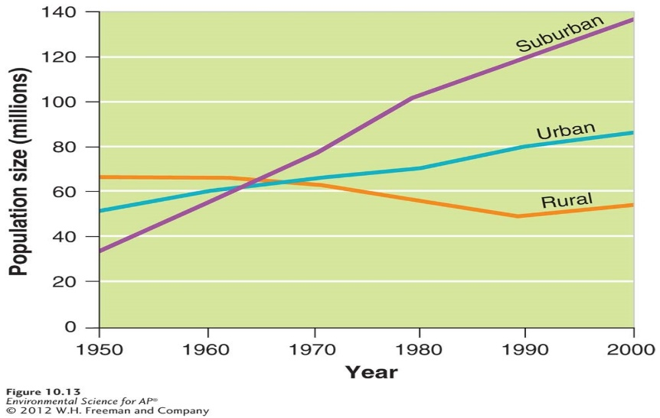

- Which of the following is true according to the graph above?
  - Rural populations were decreasing but have increased from 1990-2000
  - Suburban populations have leveled off
  - Approximately 85 million people live in suburban areas.
  - Movement to urban areas is increasing at the fastest rate
  - All development in the United States is occurring in suburban areas
- According to the graph, what is the approximate percent growth of suburb populations in the United States from 1950-2000?
  - 25%
  - 75%
  - 100%
  - 285%
  - 50%
- Which of the following correctly summarizes urban sprawl?
  - Large homes close together
  - Farmland close to a river
  - Housing and retail shops separated by miles of road
  - Decreased traffic congestion
  - Decreased gasoline use
- Which of the following is NOT a characteristic of smart growth?
  - Mixed land use
  - Walkable neighborhoods
  - Compact building design
  - A variety of transportation choices
  - Design cities without stakeholder input
- Taking a vacant lot and building on it rather than expanding into new land outside the city is known as
  - Urban sprawl
  - Urban blight
  - Transit-oriented development
  - Infill
  - Multi-use zoning
- One example of the tragedy of the commons can occur when several farmers share the same pasture for feeding sheep. The root cause of this tragedy is that
  - People are bad
  - Sheep reproduce too quickly
  - The market cannot support too many farmer
  - The value to any farmer of adding one more sheep is far greater than the cost to that farmer due to the land being communal
  - The cost of the sheep is lessened by bulk purchase power
- An example of a positive externality would be
  - Pollution removal from a natural wetland
  - Pollution caused by production and use of petroleum products
  - Loss of use of a forest after the timber is harvested
  - Hydrologic regime change from impervious surfaces
  - An urban heat island effect from blacktop
- The nation with the largest percentage of publically held land is
  - United States
  - Costa Rica
  - Russia
  - China
  - India
- When looking at both private and public lands in the US the most common use is
  - Timber production
  - Grazing land
  - Recreational
  - Defense
  - Residential
- Which is NOT a problem with clear cutting as means of timber harvest?
  - The possibility of raising water temperatures
  - Increased soil erosion
  - Lack of cover for certain wildlife
  - Herbicide us prior to replanting
  - High cost of clear cutting when compared to other methods
- Before certain projects can begin in the US, the project owner must file an EIS. The purpose of this is to
  - Discover whether the project would be well served by multi-use zoning
  - Force land owners to proceed in the way that will have the least environmental impact
  - Force land owners to file an environmental mitigation plan
  - Reduce the likelihood of creating urban sprawl
  - Force land owners to suggest alternative approaches to the project and assess the environmental impacts of those alternatives
- Currently, most of the US populations lives in ______ areas
  - Rural
  - Suburban
  - Exurban
  - Urban
  - Superurban
  - Keith Urban
- Public lands in the US are categorized for use based on the managing agency. In general Bureau of Land Management (BLM) lands are used for
  - Grazing, mining, timber harvesting, and recreation
  - Timber harvesting, grazing and recreation
  - Recreation and conservation
  - Wildlife conservation, hunting and recreation
  - Primarily preservation
- Public lands in the US are categorized for use based on the managing agency. In general National Park Service ( NPS) lands are used for
  - Grazing, mining, timber harvesting, and recreation
  - Timber harvesting, grazing and recreation
  - Recreation and conservation
  - Wildlife conservation, hunting and recreation
  - Primarily preservation
- The US government receives royalties for use of public lands from timber companies. In general this translates into
  - 5% profit for the government ( after considering costs of management and upkeep)
  - 15% profit for the government ( after considering costs of management and upkeep)
  - 25% profit for the government ( after considering costs of management and upkeep)
  - 50% profit for the government ( after considering costs of management and upkeep)
  - Net loss for the government ( after considering costs of management and upkeep)
- National wildlife refuges are managed primarily for the purpose of protecting wildlife. They are usually managed by
  - FWS
  - BLM
  - USFS
  - NPS
  - Whichever agency managed the land before the refuge was established

