Chapter 12 and 13 review

- Which of the following is not a nonrenewable energy resource?
  - Oil
  - Coal
  - Natural gas
  - Wind
  - Nuclear fuels
- The fact that global transfer of energy from a fuel to electricity is about 35% efficient is mostly a consequence of
  - Hubert curve
  - The law of conservation of matter
  - The first law of thermodynamics
  - The second law of thermodynamics
  - The law of limiting factors
- Which of the following is the most fuel-efficient mode of transportation in terms of joules per passenger-kilometer?
  - Train
  - Bus
  - Airplane
  - Car with one passenger
  - Car with three passengers
- Which of the following is not associated with the surface extraction of coal?
  - Low death rates among miners
  - Land subsidence and collapse
  - Large piles of tailings
  - Underground tunnels and shafts
  - Acid runoff into streams
- Which of the following statements regarding petroleum is correct?
    - It is formed form the decay of woody plants
    - It contains natural gas as well as oil
    - It migrates through pore spaces in rocks
- i,ii, and iii
- i and iii
- ii only
- i and ii
- ii and iii
- Nuclear power plants produce electricity using energy from the radioactive decay of
  - Uranium -235
  - Uranium -238
  - Uranium -239
  - Plutonium – 235
  - Plutonium – 238
- Currently, most high level radioactive waste from nuclear reactors in the United States is
  - Stored in deep ocean trenches
  - Buried in Yucca Mountain
  - Reprocessed into new fuel pellets
  - Chemically modified into safe materials
  - Stored at the power plant that produced it
- A radioactive isotope has a half-life of 40 years and a radioactivity level of 4 curies. How many years will it take for the radioactivity level to become 0.25 curies?
  - 80 y
  - 120 y
  - 160 y
  - 200 y
  - 240 y
- Which of the following energy sources is responsible for the largest fraction of electricity generation in the United States?
  - Natural gas
  - Coal
  - Uranium
  - Oil
  - Wood
- In 1969, M. King Hubbard published a graph known as the Hubbert curve. This graph shows
  - The amount of nuclear fuel available in North America
  - The amount of nuclear fuel available in the world
  - The point at which world oil production will reach a maximum and the point at which we will run out of oil
  - The point at which world oil production will increase
  - The coal reserves found in the United States, china, and Russia
- Which of the following is not an example of a potentially renewable or nondepletable energy source?
  - Hydroelectric
  - Solar energy
  - Nuclear energy
  - Wind energy
  - Geothermal energy
- The order of grades of coals from lowest energy content to highest energy content is
  - Anthracite, lignite, sub-bituminous, bituminous
  - Anthracite, sub-bituminous, bituminous, lignite
  - Sub-bituminous, bituminous, lignite, anthracite
  - Bituminous, sub-bituminous, lignite, anthracite
  - Lignite, sub-bituminous, bituminous, anthracite
- Renewable energy sources are best described as
  - Those that are the most cost-effective and support the largest job market
  - Those that are, or can ,be perpetually available
  - Those that are dependent on increasing public demand and decreasing supply
  - Those that are being depleted at a faster rate than they are being replenished
  - Those that are reusable, and therefore eliminate waste energy released into the environment
- An energy-efficient building might include all of the following except
  - Building materials with low thermal inertia
  - A green roof
  - Southern exposure with a large double-paned windows
  - Reused or recycles construction materials
  - Photovoltaic solar cells as a source of electricity
- Which of the following sources of energy is not (ultimately) solar-based?
  - Wind
  - Biomass
  - Tides
  - Coal
  - Hydroelectricity
- Which of the following demonstrate(s) the use of passive solar energy?
    - A south-facing room with stone walls and floors
    - Photovoltaic solar cells for the generation of electricity
    - A solar oven
- i only
- ii only
- iii only
- i and iii
- ii and iii
- A study small wind turbines in the Netherlands tested the energy output of several models. The results for two models are shown in the graph below. Which of the following statements can be inferred from this data?

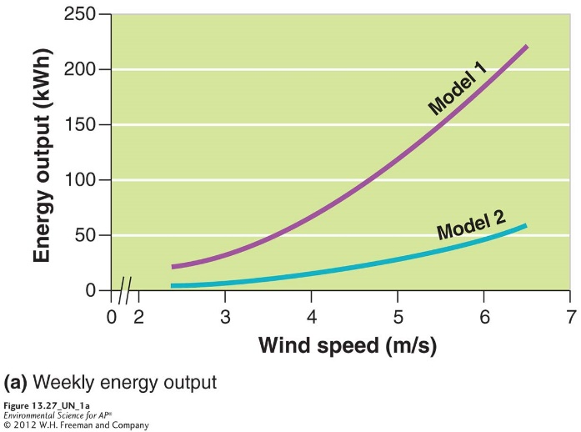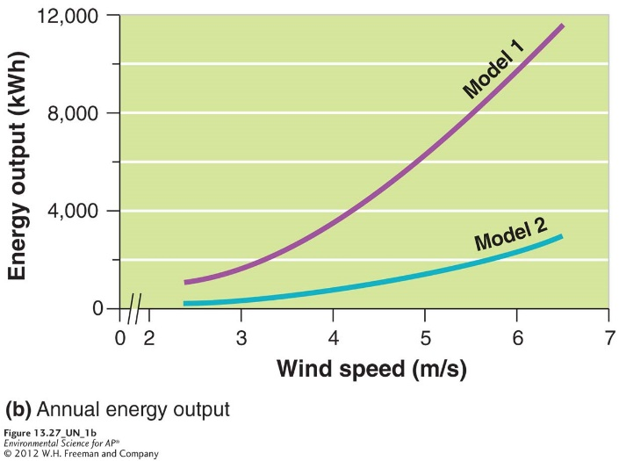

  - As wind speed increase, energy output decreases.
  - The annual energy output of model 1 can exceed 6,000kWh
  - As energy output surpasses 50kWh per week, noise pollution increase.
  - Model 2 is likely to cause more bird and bat deaths
  - Model 1 is more cost-effective
- The primary sources of renewable energy in the United States are
  - Solar and wind energy
  - Hydroelectricity and tidal energy
  - Biomass and hydroelectricity
  - Geothermal and tidal energy
  - Wind and geothermal energy
- The environmental impacts of cutting down a forest and burning the wood for hearing and cooking could include
    - Deforestation and subsequent soil erosion
    - Release of particulate matter into the air
    - A large net rise in atmosphere concentrations of sulfur dioxide.
- i only
- ii only
- iii
- i and ii
- ii and iii

Use the diagram below, which represents annual U.S. energy consumption by source and sector for 2007, to answer questions 20-22.
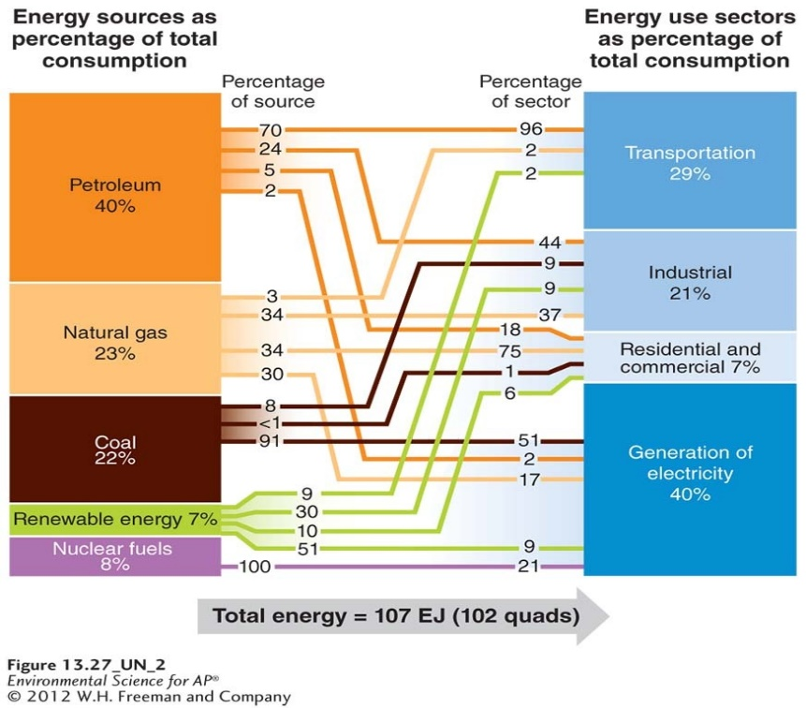
- Which of the following statements best describes the sources of energy in U.S. energy consumption patterns?
  - Most of the renewable energy is used in the industrial, residential and commercial sectors.
  - Most of the electricity generated in the United States comes from nuclear energy
  - The industrial sector is heavily dependent on coal and renewable energy
  - Fossil fuels continue to be the major energy source for all sectors.
- Which of the following best describes U.S. energy use?
  - Transportation is the largest end use of energy in the United States
  - Transportation is fueled mainly by coal
  - Electricity generation is the largest end use of energy in the United States
  - Electricity generation is powered mainly by nuclear energy
  - Industry is the largest end use of energy in the United States
- Which of the following statements best describes the role of renewable energy in the United States?
  - It is the dominant energy source
  - It is the largest contributor of greenhouse gases.
  - It is a large contributor to the transportation sector
  - Its largest contribution is to the electricity generation sector
  - It is never sustainable
- In order to best achieve energy sustainability, humans must consider which of the following strategies?
    - Building large, centralized power plants
    - Improving energy efficiency
    - Developing new energy technologies
- i only
- ii only
- iii only
- i and ii
- ii and iii
- If the average person in the United States uses 10,000 watts of energy, 24 hrs a day for 365 days per year, how many KW of energy does the average person use in a year?
  - 10 KW
  - 1,000 KW
  - 3,650 KW
  - 3,650,000 KW
  - 87,600 KW
- In developed countries, _____% of world’s population use____% of the world’s energy each year.
  - 5, 50
  - 20,70
  - 5, 70
  - 1, 50
  - 50,90
- The energy source that is used most in the United States is
  - Coal
  - Oil
  - Natural gas
  - Nuclear
  - Renewables
- Fuel efficiency (mpg) of U.S. automobiles have
  - Decrease in the last 5 years
  - Increased in the past 30 years
  - Increased then decreased in the past 30 years
  - Remained relatively stable since 1990
  - Dropped dramatically since 1990
- All of the following are a part of a coal-fired electricity generation plant EXCEPT:
  - Pulverizer
  - Boiler
  - Control rods
  - Turbine
  - Generator
- An example of cogeneration would be
  - Using steam from industrial purposes to heat buildings
  - Using both coal and oil to create electricity
  - Increasing nuclear power plants in major metropolitan areas
  - Substituting anthracite coals for low grade lignite coal
  - Operating power plants at 30% of maximum sustainable yield
- Put the following types of coal in order from most moisture, least heat to least moisture, most heat
  - Peat, lignite, bituminous, anthracite
  - Peat, bituminous, lignite, anthracite
  - Anthracite, bituminous, lignite, peat
  - Bituminous, anthracite, lignite, peat
  - Bituminous, lignite, peat, anthracite
- Which of the following statement(s) regarding petroleum is/are correct?
    - It comes from the remains of ocean-dwelling phytoplankton that died millions of years ago
    - It is found in porous, sedimentary rock
    - It burns cleaner than natural gas
- i only
- ii only
- iii
- i and ii only
- i, ii, and iii
- Natural gas is generally found with
  - Oil
  - Coal
  - Both oil and coal
  - Uranium mines
  - Aquifers
- Coal supplies are expected to last for at least
  - 5 years
  - 40 years
  - 60 years
  - 100 years
  - 200 years
- 1 gram of Uranium -235 contains ________ times the energy of 1 gram of coal
  - 20
  - 1,000
  - 100,000
  - 2-3 million
  - 1 billion
- The difference between coal and nuclear power when it comes to how electricity is made it
  - Coal power generates steam and nuclear power does not
  - Nuclear power uses fission to create heat to generate steam
  - Nuclear power produces more air pollution than coal
  - Coal is much more energy efficient than nuclear
  - A generator is not needed in the production of nuclear energy
- If a material has a radioactivity level of 100 curies and has a half-life of 10 years, how many half-lives will have occurred after 100 years?
  - 1
  - 4
  - 10
  - 1,000
  - 25
- Which of the following is the best example of a depletable energy source?
  - Wind
  - Wood
  - Solar
  - Geothermal
  - Nuclear
- If a homeowner plants a large, deciduous shade tree next to a southern window, he/she is using
  - Active solar design
  - Photovoltaic systems
  - Energy star technology
  - Passive solar design
  - A tiered rate system
- In developing countries, wood is the primary resource for heating homes and cooking. What major environmental impact is associated with deforestation?
  - Erosion
  - Acid rain
  - Depletion of the stratospheric ozone layer
  - The municipal waste that is created
  - Invasive species taking over the area
- Most ethanol produced in the United States comes from _________ while in Brazil most ethanol comes from _______.
  - Oil deposits; corn
  - Oil sands; sugarcane
  - Corn; sugarcane
  - Biomass; wood chips
  - Wood chips; corn
- Which of the following are environmental consequences of dams?
    - Release of greenhouse gases
    - Disruption to many aquatic species life cycles
    - Accumulation of sediments in the reservoir
- i only
- ii only
- iii only
- i and iii only
- ii and iii
- A photovoltaic cell would be used to
  - Capture sunlight and turn it into electricity
  - Burn biomass fuel
  - Generate passive solar energy
  - Generate wind power
  - Generate electricity behind a dam
- The country that leads the world in the production of geothermal energy is
  - The United States
  - Iceland
  - China
  - Russia
  - Ireland
- Some energy experts say that a better system of generating electricity would be to
  - Have one large, centralized power plant
  - Stay our existing technology
  - Switch to geothermal sources
  - Have large numbers of small-scale electricity generation with fossil fuel and renewable energy resources
  - Switch to hydrogen fuel cells
- A hydrogen fuel cell take hydrogen and oxygen and makes
    - Electricity
    - Energy
    - Water
- i only
- ii only
- iii only
- i and ii only
- i, ii, and iii
- a flex-fuel vehicle
  - is known as a hybrid
  - uses hydrogen fuel cells for power
  - runs on gasoline or E-85
  - can drive farther on one tank of gas
  - runs on photovoltaic cells

