EcoColumn Assignment

A stroll through a woods, field, wetland, prairie or even desert can reveal dozens of birds, hundreds of plants, thousands of insects and billions of microbes al living and associating in an area smaller than a coat closet.

This small area hosts an astoundingly complex web of interrelations and dependencies. When the entire system is considered, the complexity can be mind-boggling.

How can one even begin to understand a system that is so complex?

Ecologists frequently begin to understand a complex system by first creating a simplified model of that system. In building this model, we begin to learn more about a real system and how it works. With the Bottle Biology EcoColumn we can begin to create simple models of complex ecosystems.

The EcoColumn allows you to explore a fascinating variety of dynamic ecosystems which begin to model many kinds of aquatic and terrestrial environments. You can create habitats and niches for insects, spiders, aquatic organisms as well as large plants, small algae and microbes. Individual modules can be used separately or stacked into a stable, free- standing column. Stacked modules can be kept sealed or can be inter- connected to stimulate interactions between systems.

The tapered sides of EcoColumn chambers allow a close-up view of organisms from aquatic environments. Roots of plants are also made visible, and a module can be viewed from underneath as well. Columns can be constructed and observed, noting changes over time.

The whole goal of ecology (and this class) is to understand how organisms interact with one another and their non-living environment—in effect it is a study of connections in nature. This lab will provide an opportunity to explore connections in nature by creating an artificial model of an ecosystem.

This lab will hopefully give you insight into the conditions required for sustainability and the interconnections between various ecosystem components (column chambers). We will take the next several months to make observations about our Ecocolumns, which will lead to a clear understanding of the factors which influence ecosystems. You will be asked to observe your columns for a period of several weeks and attempt to make ecological sense of the changes that you observe.

BIOLOGY Ecocolumn Project

PROJECT PURPOSE: To use a model of real-world ecosystems in order to understand how biotic and abiotic factors interact and to see how one type of ecosystem impacts other ecosystems.

Instructions:
- See handouts for bottle assembly instructions. You will want to create a 3 tiered column: decomposition, terrestrial and aquatic (from the top down). Each will have living (biotic) and non-living (abiotic) components. Additionally, you will also include a precipitation section.

- As you actually construct your column in class, you will want to record, in detail, EXACTLY what you will be adding (and in what quantities) to your column.
  - This is when you will create a section in your notebook titled “EcoColumn Inventory” and it will contain the following:
    - A drawing of your entire EcoColumn, detailing all of the parts. Specify where you used tape, any holes that were made (and the tools used to make these holes and the sizes of these holes).
    - An inventory list for each of the 4 sections of your EcoColumn, detailing how many of each organism are included in your EcoColumn, the sizes of each of these organisms, # of plants/seeds added, the amount of soil, gravel, pond water or fresh water included and any other information which you believe to be of importance.
  - Aquatic chamber must include substrate material (i.e. sand/gravel/aquarium rock), one goldfish (optional), and aquatic plant(s). You may add other organisms or abiotic factors.
  - Terrestrial chamber must include soil (i.e. potting soil, soil from your home, etc) and seeds or plants. You may add other organisms or abiotic factors.
  - Decomposition chamber must include leaf/grass material, potting soil, fruit flies or other animal, and a piece of fruit (i.e. apple, banana) or a piece of potato.
- Once assembled, add a specific amount (record the amount in your journal) of precipitation (aka “rain”) to the column. Throughout the data collection period, you may add precipitation when you think necessary, but again be sure to record the dates and quantity of water added.
- We will monitor the column for a prescribed amount of time. It is your job to observe and record how the properties of the columns change over time and infer and contemplate what is behind the changes. This may involve some out of class time samplings (at lunch, before or after school).
- You will make observations (in your notebook) following the format outlined in the instructions on the following pages.
- ALSO…You should use the provided data table format as well – because you will need to include this data table in your final ecocolumn report.
- Over the course of the experiment, you will have “sampling events” where you look for changes in each chamber and collect both qualitative and quantitative data. We will test the pH of the water, temperature, turbidity, odor, etc.

By the end of this set-up we will have completed the following:
- Detailed instructions for ecocolumn assembly. This should tell someone else how they could construct an ecocolumn that would look exactly like the one you created.
- Diagram of ecocolumn. (See the following examples)
- Inventory lists for each of the sections of your ecocolumn.

Observations:

Over the next 3-4 weeks, you will monitor all possible abiotic and biotic factors pertaining to your ecosystem column. Data is to be recorded regularly (see form attached) and is to be included in the final lab report. Use the attached data sheet as an example to help organize your record keeping all data collected an associated analysis charts/ graphs will in your formal lab write up.

Ideas for Chamber Components:
Aquatic habitat
- Fine grained aquarium gravel (provides “bedrock”)
- Sand or topsoil (provides bottom sediment)
- Untreated tap water or distilled water (provides aquatic habitat)
- “Boulders,” “sunken logs,” and other miniature objects typical of a pond bottom
- Aquatic plants and animals
Compost habitat

- Fine grained aquarium gravel (provides “bedrock”)
- Sand/topsoil mix (provides soil substrate)
- Leaf litter (provides compost habitat)
- A few chunks of turnips, potato, apple, or other roots, stems, or fruits
- Twigs
- Earthworms, pill bugs, millipedes, and other natural inhabitants of leaf litter
Terrestrial habitat
- Fine-grained aquarium gravel (provides “bedrock”)
- Topsoil (provides soil substrate)
- Leaf litter (provides decaying material)
- “Boulders,” “dead trees,” and other miniature objects typical of a forest habitat
- Terrestrial plants and animals
- Food for animals as needed

Assembly of Ecocolumn
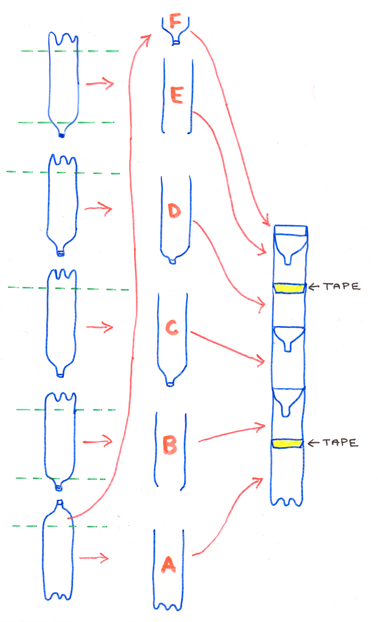
(example of diagram to accompany ecocolumn assemblyinstructions)

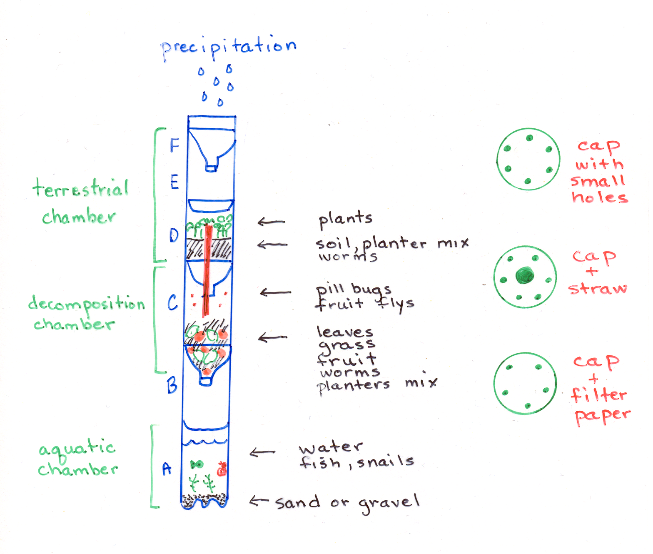
Ecocolumn DIAGRAM
(example of diagram of completed ecocolumn)

The pictures of the caps should have arrows to the ecocolumn area where they are located. Also, when writing instructions for ecocolumn assembly, you should include pictures of the caps and details about how the holes were put in the caps and what is in the caps.
BIOLOGY Ecocolumn Project

Name.
Title.
Introduction.
- The introduction should be a coherent paragraph. These topics should be covered in the introduction:
  - Differences between the chambers
  - Food chains and food webs present
  - Biogeochemical cycles in action
  - Is there any evidence for competitive exclusion principle or resource partitioning?
  - What limiting factors exist?
Materials.
- This should be a bulleted list of all materials needed to create your ecocolumn.
Procedure.
- Instructions should be in a logical sequence.
- Someone should be able to set up the exact same ecocolumn you did if they followed your instructions.
- Instructions should be concise and yet provide specific details regarding the materials and quantities used. Some things to consider including:
Contents and quantity in the aquatic chamber
Contents and quantity in the decomposition chamber
Contents and quantity in the terrestrial chamber
- HINT: Try writing out the instructions and then run a mock set up with someone who hasn’t done this project. Discover any changes you need to make and revise them before you turn in this portion of the assignment.

Labeled Diagram of Ecocolumn.
- SEE diagram samples.
- Diagram has a title which tells the reader what the drawing is
- Diagram reveals set up of ecocolumn.
Bottle arrangement
Location of straw, filter paper, etc.
Hole arrangement in bottle caps
- Labels for key features
Each chamber
Contents within each chamber
Observations.
- Should contain DATED observations made by various group members following the format prescribed in the “EcoColumn Data Collection” sheets (found at the end of this packet)
- Should contain at least three pictures to support your observations
Conclusion.
- Should be a coherent paragraph which sums up the purpose of the project and all that you have learned.
  - Should answer the questions “What did my group learn by doing this ecobottle?”, “If we were going to do another ecobottle project, what would we do differently?” and “What questions for further research does this project raise for us?”
  - Compare and contrast your simulated ecosystems with natural ecosystems outside the class room.
  - Open or closed system? Which applies to you ecosystem column
  - Describe available niches.
  - Compare and contrast your lab group’s column with others.
  - Discuss the stability and sustainability of your ecosystem column
  - Discuss what you would change, add, or subtract.
  - Discuss three trends or patterns which stand out as you think back on the data which you have been recording.

ECOCOLUMN PROJECT POINT SHEET

DUE  DATE | PROJECT TASK | Points Earned | Points Possible
 | Detailed Instructions  - Title (2 pts).  - Introduction (10 pts).  o Differences between the chambers  o Food chains and food webs present  o Biogeochemical cycles in action  o Is there any evidence for competitive exclusion principle or resource partitioning?  o What limiting factors exist?  - Instructions are presented in logical, sequential format and do not leave out major set up steps. (2 pts)  - Substance quantities are included (2 pts)  - Materials: What to include in each chamber is included (4 pts)  - Instructions are easy to read (1 pts) and follow because these are legible and numbered (1 pts).  - Procedure (6 pts). |  | 28
 | Labeled Diagram  - Each chamber is accurately labeled (6 pts)  - Contents of Aquatic chamber are shown and labeled (1 pts)  - Contents of Decomposition Chamber shown and labeled (1 pts)  - Contents of Terrestrial Chamber are shown and labeled (1 pts.)  - Position and arrangement of soda bottles in sketch and labeled (1 pts)  - Bottle cap holes, straws, filter paper included in sketches and labeled (1 pts)  - Neatness and color (5 pts) |  | 16
 | DATA Collection and Observations (at least 12 times @ 2 points/time)  Criteria  - Data recorded on the specified date  - Observations and measurements are accurate and complete.  - Observations are made on the following “Data Collection” sheet. |  | 56
 | Conclusion  - Should be a coherent paragraph (typed preferably)  - Should answer the questions “What did my group learn by doing this ecobottle?”, “If we were going to do another ecobottle project, what would we do differently?” and “What questions for further research does this project raise for us?”.  - See conclusion description |  | 50
 | TOTAL |  | 150

Eco-column Data Collection

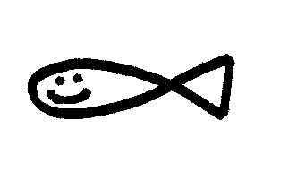
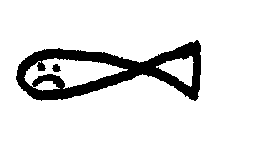
Aquatic Fauna → Live or Dead

Turbidity Scale → Crystal Clear = 1 Odor Scale → No Odor = 1
Slightly Cloudy = 2 Slight Odor = 2
Moderately Cloudy = 3 Smelly = 3
Very Cloudy = 4 Very Smelly = 4
Blackish or Brownish = 5 Devastating = 5

Date | WaterTemp °C | pH | Turbidity | Odor | Aquatic Organisms  Observations | Terrestrial Organisms  Observations | Micro-organisms  Observations | Dissolved Oxygen | Decomposition  Litter/ mass  Observations | H₂O added (mL)

Eco-column Data Collection
Aquatic Fauna → Live or Dead

Turbidity Scale → Crystal Clear = 1 Odor Scale → No Odor = 1
Slightly Cloudy = 2 Slight Odor = 2
Moderately Cloudy = 3 Smelly = 3
Very Cloudy = 4 Very Smelly = 4
Blackish or Brownish = 5 Devastating = 5

Date | Temp °C | pH | Turbidity | Odor | Aquatic Fauna | Aquatic Flora | Micro-organisms | Terrestrial Fauna | Terrestrial Flora | H₂O added (mL)

Eco-column Data Collection
Aquatic Fauna → Live or Dead

Turbidity Scale → Crystal Clear = 1 Odor Scale → No Odor = 1
Slightly Cloudy = 2 Slight Odor = 2
Moderately Cloudy = 3 Smelly = 3
Very Cloudy = 4 Very Smelly = 4
Blackish or Brownish = 5 Devastating = 5

Date | Temp °C | pH | Turbidity | Odor | Aquatic Fauna | Aquatic Flora | Micro-organisms | Terrestrial Fauna | Terrestrial Flora | H₂O added (mL)

